Job Description BCP Council
Seafront Catering – Stores Person
Role Profile | Band E
Service/Team | Seafront – Operations
Reports to | Catering Manager
Responsible for | N/A
Number of posts | 1
Post number | - - - - -
Career Grade | N/A
My job improves the quality of life for the people of Bournemouth and Poole by… Supporting the seafront catering team in the delivery of quality services and driving income opportunities for the visitors and residents of the resort.
Job Overview
Order and maintain stock levels across the 20 Catering units on Bournemouth, Poole and Christchurch Seafront. Annualised contract. Majority of hours worked in the summer months

Key Responsibilities
- Order and maintain stock levels to Seafront Catering business demands.
- Deliver all stock items to all catering sites to maintain daily on sales levels.
- Re-order stock from our suppliers to ensure back up and kiosk stock levels are kept at the correct levels to maintain full availability throughout the trading day.
- Responsible to check deliveries against delivery notes include temperature checks.
- Transportation of stock is undertaken in an appropriate manner. Ensure food safety standards are met.
- Comply with relevant regulation including SFBB, Health & safety at work and fire safety.
- Ensure safety and welfare of the public whilst driving on Seafront.
- Ensure vehicles have daily Health and safety checks.
- Vehicles to be left secure when not in use. Keep topped up with fuel.
- Deal with any customer queries and complaints in a friendly and professional manner in accordance with the BCP seafront services customer care policy.
- To carry out all other duties as instructed by Catering Manager and Supervisors
- Remove any unwanted waste and recycling from kiosks if necessary.

Specific Qualifications and Experience
- Experience of working within a team with similar conflicting demands
- Knowledge of the Councils policies and procedures
- Previous experience of high levels of Hospitality Trade
- Full driving licence

Personal Qualities & Attributes
- Good communicator
- Flexible
- Excellent team player
- High level of resilience
- Attention to detail
- Calm under pressure

Job Requirements
- Must be willing to travel, using public or other forms of transport where they are viable, or by holding a valid UK driving licence with access to own or pool car
- To work in locations between Bournemouth and Poole as required
- Flexible working – 5 in 7 days, work over major festivals (e.g. Bournemouth Air Festival) and Bank Holidays.

This job description is not exhaustive and reflects the type and range of tasks, responsibilities and outcomes associated with this post.

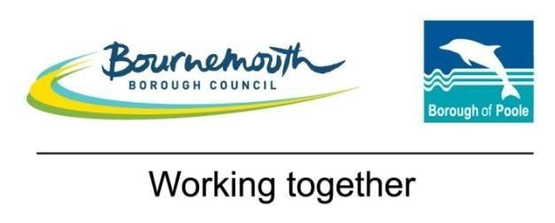
Role Profile (BSG04)
Business Support 4 (Grade 4/E)

Competencies
Managing,  Leading and  Developing  Others | Contribute to and celebrate the success of the whole team
 | Encourage and listen to new ideas from everyone and be positive about change
 | Share open and honest feedback in a constructive manner
Knowledge  and Skills | 2 A levels, NVQ 2/3 in Business Administration (or equivalent experience)
 | Good knowledge of ICT including Excel, Word, Outlook and other programmes relevant to the role
 | Straightforward collation and analysis of data
 | Prepare engaging presentations using a clear brief
 | Prepare clear and succinct meeting notes
 | Experience of diary management for senior officers
 | Attention to detail with the ability to proof read
Creativity and  Innovation | Use curiosity about the way things are done to recommend, create and implement more effective ways of working that will enhance customer experience
 | Use effective interpersonal skills to develop solutions to a range of practical problems
Relationships | Build supportive, positive and trusting relationships with others
 | Seek to resolve any barriers to collaborating with others by communicating openly and challenging unhelpful behaviour
 | Appreciate diversity in both customers and colleagues and consider their specific needs
Decision making | Make evidence based decisions within set procedures, escalating to a manager where appropriate
Work  Demands | Plan and organise own workload including some prioritisation of non standard work
Version 1 – September 2017

