SEN/ SEMH Learning Support Assistant (LSA)
Grade 3, Scale Point 4-6
Full Time Equivalent: £24,405
Actual: £16,925 (30 hours per week)
Application Pack
Closing Date – 9am Friday 11 July 2025
Interview Date - TBC

Contents

Welcome to St Michael’s Church of England Primary School 3

Our Church School Vision 4
School Values 4
Aims 4

About St Michael’s Church of England School 5

Person Specification for Learning Support Assistant 7
Job Description for Learning Support Assistant……………………………………………9

Welcome to St Michael’s Church of England Primary School

I am thrilled that you have decided to apply for the role of Learning Support Assistant at our school.

You will be part of a thriving community of over ninety members of staff and over six hundred and thirty children and their parents. No two days are ever the same and this variety and diversity makes the school the incredible place we all love.

My vision is encapsulated in the aims and vision statement below. Your role will be to work as part of a diligent team of teachers and support staff that make these aims a daily reality for our children.

I look forward to receiving your application, and welcome visits by appointment with the school office.

Our school is committed to safeguarding and promoting the welfare of children and the successful applicant will be subject to an enhanced with barred list check from the Disclosure and Barring Service. As part of our Safer Recruitment process, please take the time to read through our ‘Safeguarding and Child Protection Policy’, which can be found by following the below link:

https://www.stmichaelsprimary.bournemouth.sch.uk/policies/

Our School also completes an online search on shortlisted candidates, as part of our due diligence checks.

Yours faithfully

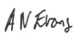
Anthony Evans
Headteacher

Our Church School Vision
Our vision is used across all policies and guides our work. Our vision is:

Like a lighthouse, St Michael’s is a beacon of safety and stability. It takes courage to learn and remember knowledge, develop new skills and allow your own light to shine in the world. We respect our differences and know that working peacefully together allows our lights to shine more brightly.

‘Let your light shine’ Matthew 5:16

School Values
Our school values are Peace, Courage, and Respect

Aims
We have simplified our vision and values into our school aims listed below:

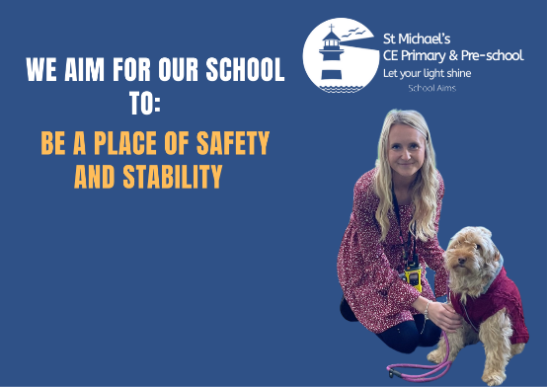
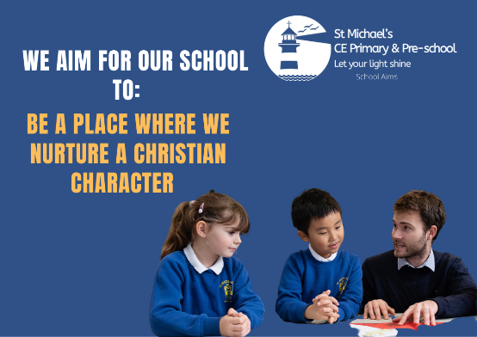

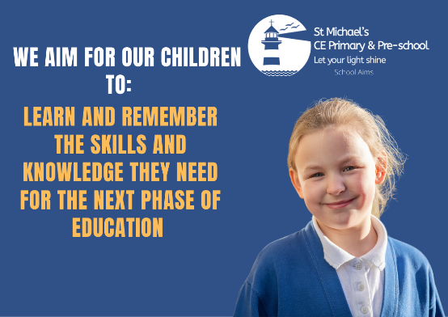
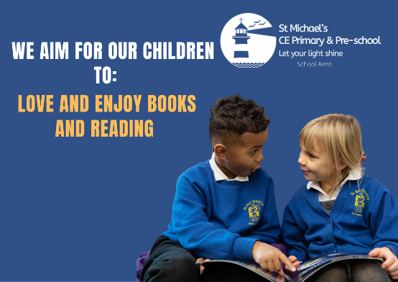
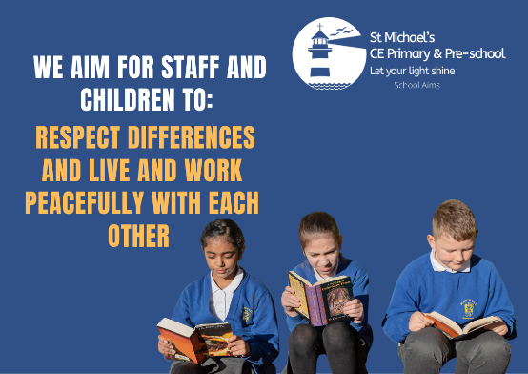

About St Michael’s Church of England School
St Michael’s School has been educating, serving and nurturing the children of Bournemouth for almost 150 years, existing on its current site since 1878. Many years and building projects later, St Michael’s is now a modern, well-equipped, three-form entry primary school. The school welcomes children from Reception to Year 6.
Situated in central Bournemouth, a coastal town boasting nine miles of sandy beaches. Bournemouth has a rich history dating back to Victorian times, when it played host to literary icons such as Mary Shelley and J R R Tolkein. Once a popular spa town, it remains a desirable holiday destination and a vibrant place to live.
Owing to its unique location, the children of St Michael’s are able to take advantage of all Bournemouth has to offer. From trips to the fascinating Russell-Cotes Art Gallery and Museum, to participating in events at the impressive Bournemouth Library and enjoying sports days on the beach. All right on our doorstep.
As the population of Bournemouth has evolved over the past two decades, so has that of St Michael’s. One of the school’s many strengths lies in the diversity of its pupils and their families. Between them, the children of St Michael’s are able to speak or understand over fifty languages and come from all around the world. The children’s cultures and languages are celebrated and seen as valuable assets in enhancing their learning journey as they move toward being global citizens of the future.
St Michael’s is a Church of England school with an active link to St Michael’s Church, a short walk away. At its heart are the Christian values of Peace, Courage and Respect. Our school’s Christian vision is expressed by the verse from Matthew ‘Let your light shine’ – every individual is given the space and encouragement to find their strengths and fulfil their potential.
The children work hard learning a challenging, knowledge-rich curriculum, taught by passionate, committed teachers who go over and above to provide the best learning experiences for each child in their class. Teachers and teaching assistants work in an environment of mutual respect and support, keeping up to date with the latest research-based evidence, through regular training, discussion and study, to constantly develop and improve their pedagogy and practice. They seek to adapt and respond to the changing needs of their pupils and provide the best possible, rounded education in an atmosphere of safety, stability and inclusivity.
The school’s varied and engaging curriculum is reflective of the wonderfully diverse community it serves. It has been designed to prepare children with the social, moral, cultural and academic knowledge they need to move forward confidently into secondary school and beyond. Pupils are provided with a wide range of opportunities and experiences to stimulate their curiosity, enhance their learning and inspire them to develop their aspirations.
Books are a fundamental part of school life at St Michael’s, where children enjoy reading for pleasure and are taught by teachers who love to read. Our children become confident, life-long readers themselves through a rich and diverse diet of books.
Both children and staff are supported by a dedicated Senior Leadership Team (and a dog), who lead the school forward with the clear vision of providing a place of safety and stability, of courage and respect, where children love to learn. In addition, a friendly, efficient Office Team contributes to the smooth day-to-day running of the school. All staff are an integral part of our team and vital in facilitating the exceptional educational experience St Michael’s strives to offer to each and every one of its children.

Person Specification for SEN/SEMH Learning Support Assistant

Qualifications & Training  The qualifications and / or training required to undertake the role. |  | Essential | Desirable
1 | Level 2 in qualification for teaching assistant
2 | Commitment to obtain Level 2 qualification for teaching assistant
3 | Good general education (including at Least grade C in English and Maths GCSE)
4 | First Aid qualification
5 | Basic Food Hygiene Certificate
6 | Minibus driver assessment

Achievement & Experience
The Level of experience required and / or Length of time the post holder will have been required to undertake the item specified.
1 | Experience of supporting children’s learning in a classroom setting or other proven success in working with children
2 | Experience of working with children with high special educational needs, particularly SEMH and ASD
3 | Experience of promoting engagement and interaction within pre and non-verbal children, including communication programmes e.g PECS
4 | Experience of delivering communication interventions e.g Attention Autism, PEIC-D
5 | Experience of recoding and monitoring progress using Tapestry and Connecting steps programmes

Knowledge
The knowledge and Level of understanding the post holder must have of the items specified.
1 | Knowledge of all Legislation relating to education
2 | Knowledge of safeguarding issues and policies and relevant procedures
3 | A working knowledge of relevant health & safety and basic food hygiene requirements
4 | Be able to relate easily to a range of children aged 4 – 11 years
5 | Have energy, enthusiasm, sense of humour and empathy
6 | Be able to operate with an inclusive and equal opportunities framework
7 | Have an understanding of the developmental needs of children 4 – 11 years
8 | An understanding of Special educational needs, particularly attachment theory and ASD
9 | The ability to learn and use a range of strategies to deal with classroom and  individual behaviour management  behaviour
11 | Experience of using information technology to support children in the classroom

Skills
The Level of skill that is required to undertake the item specified.
1 | Ability to communicate effectively, both verbally and in writing
3 | Ability to work on own initiative and unsupervised
4 | Excellent interpersonal skills
5 | Able to develop effective working relationships
6 | Good Literacy and numeracy skills
7 | Ability to work as an effective member of a team
8 | Ability to supervise small groups or class of children
9 | Able to create displays of children’s work
10 | Able to support trips outside the school environment
11 | Ability to respond calmly and constructively when dealing with children with SEND, particularly those with high SEMH/ASD needs
12 | Ability to seek advice and assistance to meet children’s needs – including self-care  and toileting support
13 | Ability to provide engaging 1:1 support
Qualities and Attitudes
The qualities and attitude the post holder must demonstrate.
1 | Committed to continuing professional development
2 | Good timekeeping
3 | A commitment to safeguarding and promoting the welfare of children
4 | Be willing to familiarise yourself with school policies and procedures in relation to safeguarding

Job Description for SEN/SEMH Learning Support Assistant

Post Details
Post Title: SEN 1:1 Teaching Assistant | Business Unit: Schools
Post No./Vacancy Ref: SMTA | School Type: Primary School
Grade/Payscale: £13,360 (FTE £19,264) | School Name: St Michael’s, Bournemouth
Job Purpose & Objectives
Details
Under the specific direction and supervision of the teachers, the post holder is responsible to the Head Teacher and Governing Body for his/her duties and responsibilities
The post holder works on a professional level with colleagues and seeks to establish and maintain productive and supportive relationships to promote mutual understanding of the aims of the school and to support the highest quality of teaching and learning
Assist in the support and inclusion of children with special educational needs in this mainstream school, particularly pupils with high needs SEMH/ASD

Work in close contact with one or more pupils, providing appropriately targeted support that facilitates effective learning and sustained progress
Main Duties and Responsibilities
Details
Helping children with all aspects of the curriculum whether individually or in small groups
To plan, prepare and deliver assigned programmes of teaching and learning activities to an individual pupil(s)
modifying and adapting activities as necessary, under the overall direction and supervision of a qualified
teacher

To select suitable ICT and practical resources and encourage their use by pupils in learning activities
To read stories to children individually and in small groups – enlivening stories for pre and non-verbal pupils
To assess, record and report on pupil development, progress and attainment.

To maintain accurate records of children’s social and emotional development as required and share this information with the class teacher at agreed times
To attend to the children’s personal needs (including self-care and toileting support) and, where a child is causing concern, report in the first instance to the class teacher
To attend to the children’s First Aid requirements, including the recording of all injuries and treatment given in the school accident book. To attend training and refresher courses as necessary
To attend with the Class Teacher, SENCo, Parent and external services, meetings to provide input regarding a child’s needs, as perceived by the school
To accompany groups of children on educational visits after prior briefing from the teacher(s) leading the trip.
To support children’s play on the playground at breaktimes and lunchtimes
Through reflective practice, support a creative inclusive curriculum which values learning through smaller group working practices
To develop and promote positive working relationships with staff, pupils and parents

To record information on the school’s computer system and access data as requested by a teacher

Support the role of parents/careers in pupil learning and contribute to meetings with parents/carers,
providing constructive feedback on pupil progress/achievement etc.

Support pupils consistently whilst recognising and responding to their individual needs
Encourage pupils to interact and work co-operatively with others and engage all pupils in activities.
Use specialist (curricular/learning) skills/training/experience to support pupils and enhance their learning and progress.
To attend CPD training at the direction of the Head Teacher and Deputy Head Teacher
To understand and provide support at appropriate levels according to the students Individual Education Plan (IEP) or
Education, Health and Care Plan (EHCP)

General Information for all Posts
This is an outline job description only and the post holder will be expected to undertake the duties commensurate within the range and grade of the post or any lesser duties as directed by the Head Teacher.
NB: The aim of the job description is to indicate the general purpose and level of responsibility of the post. Please be aware that duties may vary from time to time without changing their character or general level of responsibility. Duties may be subject to periodic review by the Head Teacher or nominated representative (in consultation with the post holder) to reflect the changing work composition of the school.

