

**Parkstone Grammar School**

**SEN Support Assistant**

Applicant Pack

**Parkstone Grammar School**

Sopers Lane, Poole, Dorset, BH17 7EP

01202 605605

recruitment@parkstone.poole.sch.uk

**Headteacher’s Welcome**

As the headteacher of Parkstone Grammar School, it is my great pleasure to welcome you to our vibrant and dynamic school community. At Parkstone, we are committed to providing an exceptional educational experience that nurtures the intellectual, social, and emotional growth of every student.

We are a heavily oversubscribed 11-18 selective girls’ school offering outstanding education to the students of Poole and its surrounding area. Founded in 1905, Parkstone has continued to provide excellent academic results within a warm, friendly and vibrant community. We are a six-form entry school with 1250 students including 350 in the sixth form.

Our school is a place where students are encouraged to explore their passions, expand their knowledge, and develop critical thinking skills that will serve them well throughout their lives. We have a team of dedicated and highly qualified teachers and support staff who are passionate about education and are committed to inspiring and challenging our students.

We believe in creating a supportive and inclusive environment where each student feels valued and respected. Our students are rightly proud of their school which provides for them a broad and balanced curriculum promoting independence, intellectual curiosity and a love of learning. Subjects offered at GCSE and A Level include academic and facilitating subjects from a very wide range. Our sixth form collaboration with Poole Grammar School for Boys allows us to offer an extensive A Level curriculum.

Students at Parkstone are not only encouraged to succeed academically, but to enjoy the wide range of musical, theatrical, sporting, speaking and charitable opportunities. They thrive in an environment of support and challenge, becoming resilient learners well prepared to succeed in the 21st Century.

The unique single-sex selective environment allows the students to grow in a safe and supportive atmosphere. Parkstone’s national reputation for excellence and continued success is testament to the consistent dedication of students, staff and governors.

Ofsted commented that Parkstone offers a ‘stimulating, friendly community in which all students are valued and may thrive intellectually, emotionally and physically’. Our school’s focus is always on teaching and learning as we strive to challenge these able students to become confident, happy and successful young people.

I invite you to apply to our school, and experience the warm and welcoming atmosphere that makes Parkstone truly special. If you're ready to embark on a rewarding journey where your passion for education meets limitless possibilities, we encourage you to explore the opportunities at Parkstone. Join us in making a difference to our young people and shaping the future together.

**David Hallsworth, Headteacher**

**Our Vision**

At Parkstone, we embody the values of Commitment, Courage and Compassion to enable students to adapt and thrive in an evolving world, providing an education that inspires and empowers students to determine and achieve their goals.

**COMMITMENT**

“Be tenacious and relentless in your curiosity for knowledge”

**COURAGE**

“Feel confident to achieve your very best and develop your resilience to overcome barriers”

**COMPASSION**

“You should encourage and care for your peers, value and engage with all cultures and religions in our diverse global community”

“Parkstone has encouraged and inspired me to love learning. There is a great community and I am always supported – just like a family.”

Year 7 Pupil

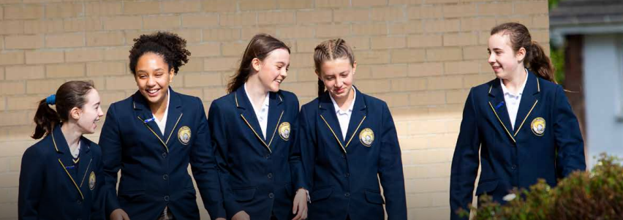

**Our Guiding Principles**

* Parkstone will be a seat of exceptional learning where great teachers enjoy autonomy in the classroom to inspire and challenge our able students.
* Very high-quality staff development and peer support to facilitate highly effective learning over time.
* Effective feedback to move students forward in their knowledge and skill development.
* Parkstone will achieve amongst the best schools in the country for the national progress measures at GCSE and A Level.
* A positive ethos underpinned by our values of Courage, Commitment and Compassion.
* Personalised support with highly effective intervention to enable equal access to learning.
* Students will have an understanding of global and national diversity and will be well prepared for life in an ever-evolving world.
* A strong community supported by the staff and student leadership teams.
* Compassionate, high quality advice and guidance to make informed and confident decisions regarding life after Parkstone.
* Opportunities outside the classroom which provide holistic development.
* To engage in initiatives and charity projects to contribute to the local and wider community.
* A broad, balanced and inspiring curriculum appropriate to Parkstone.
* An inspiring learning environment underpinned by a research culture and reflective practice.
* Our community will have high expectations of everyone in line with our Values and Charter.
* To instil a sense of stewardship towards our local, national and global environment.

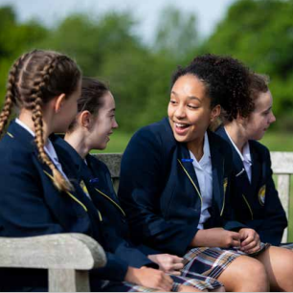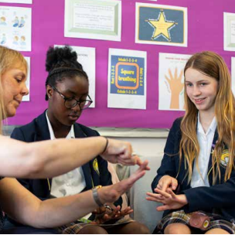

“Teachers are knowledgeable and enthusiastic. They inspire and sustain a love of learning in their pupils.”

Ofsted Report

**Our School Charter**

In our community it is important that we should maintain high standards and take responsibility for our own actions.

OUR COMMUNITY RESPONSIBILITIES

* To uphold the values of our school
* To treat all persons and the environment of the school with respect
* To apply ourselves to all areas of school life
* To empower all to do our best and to take care of each other
* To challenge any inequality and prejudiced attitudes

OUR RIGHTS

* To be treated with respect by all members of our community
* To feel safe both emotionally and physically in our school environment
* To participate in all the opportunities that our school offers
* To know where we can access support and guidance
* To be challenged appropriately where we fall short of our responsibilities

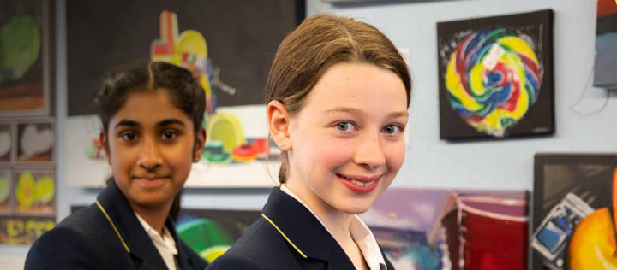

“Parkstone was the very best option for our daughter and has helped her grow in confidence and equipped her for university and life beyond!”

Parent

**Ofsted**

**Key findings of this Outstanding School**

“Under the headteacher’s calm, authoritative and exceptionally effective leadership, the school has improved rapidly since the previous inspection”.

“Leadership at all levels is very strong. Governors, senior leaders, middle leaders and other staff work harmoniously together to provide high-quality education for pupils”.

“Pupils make remarkable progress by the time they take their GCSEs in Year 11. This is sustained in the sixth form”.

“By the time they leave school, pupils have attained consistently at the highest levels and are extremely well prepared for the next stage of their education or employment”.

“Disadvantaged pupils make exceptional progress during their time at the school. Their rates of progress are much higher than other pupils nationally with the same starting points”.

“School leaders make very good use of targeted training to develop teachers’ professional knowledge and skills. As a result, teaching continues to improve”.

“Teachers are knowledgeable and enthusiastic. They inspire and sustain a love of learning in their pupils. Teachers have an unswerving faith in the ability of their pupils to succeed and give their time unselfishly to ensure that this happens”.

“Pupils are confident and articulate learners. They take great pride in their work and are determined to succeed”.

“Pupils’ behaviour is impeccable and their positive attitudes to learning are exemplary. They are hungry to learn and attendance rates are high, including in the sixth form”.

“The sixth form is outstanding. Students follow very well developed 16 to 19 study programmes”.

“Disadvantaged students prosper in the sixth form and in recent years all have gone on to university”.

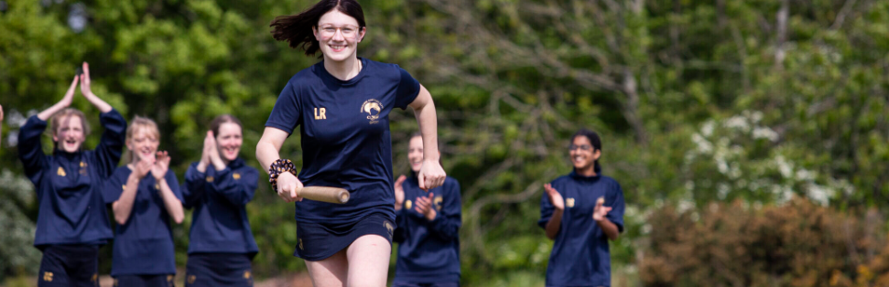

**Benefits**

Parkstone is pleased to be able to offer all staff members a

**Core Benefits**

* A contributory pension scheme relevant to your role (including access to Teacher and Local Government Schemes).
* Occupational sick pay.
* Tailored Continuous Professional Development (CPD) through the SIGMA Training School Alliance.
* Free access to the Employee Assistance Programme (EAP) - confidential support network that offers expert advice and compassionate guidance 24/7 covering a wide range of issues, such as: Legal Information, Bereavement Support and Online CBT among much more.
* All staff are entitled to a ‘Golden Day’ once a year – a paid day off or part time equivalent.
* Free Yoga and Pilates sessions throughout the term.
* Termly Staff Wellbeing and Workload groups to raise and solve issues.

**Flexible Benefits**

* Cycle to work scheme

**SEN Support Assistant**

The main purpose of this post is to provide academic support to students of all ages who are identified as having additional Educational Needs, working with a range of stakeholders, parents, teachers and support staff to ensure progress and continuity. The post holder will provide general support to identified students in lessons and in the Student Support Room and should be an emotionally available adult for students when required.

**Scale E, Points 7 – 11**

**Actual Salary: £20,708 - £22,144 gross per annum**

**(£24,294 - £25,979 FTE)**

37 hours per week

8.00am to 4.30pm Monday to Thursday and 8.00am to 4.00pm on Friday with one-hour unpaid lunch.

39 working weeks per year, which is term-time plus 5 training days.

To apply for this role, please complete the application form, which can be found on our school website, and send to [recruitment@parkstone.poole.sch.uk](mailto:recruitment@parkstone.poole.sch.uk)

**Job Description**

**SALARY AND HOURS OF WORK**

***Scale E, Points 7-11***

37 hours per week - 8.00am to 4.30pm Monday to Thursday and 8.00am to 4.00pm on Friday with one-hour unpaid lunch.

39 working weeks per year, which is term-time plus 5 training days.

###### MAIN JOB PURPOSE

* To assist in delivering the provision for pupils identified as having Special Educational Needs (SEND); including promoting high quality teaching, effective use of resources, and high standards of learning and achievement for all pupils.

**EXPERIENCE, KNOWLEDGE AND SKILLS REQUIRED**

* Have experience of working with children with special educational needs in a Secondary School setting;
* Already have qualifications in one or more areas of SEND or experience in delivering SEND based interventions;
* Have an interest in how children learn and behave;
* Provide an appropriate role model of behaviour, control and resilience at all times;
* Really care about students, particularly those who have barriers to learning effectively;
* Respect and maintain professional confidentiality but have regard to the safe guarding protocols of information sharing where necessary;
* To attend in service training and meetings relevant to the post in order to keep up to date with developments in working with children with special educational needs.

# MAIN RESPONSIBILITIES AND DUTIES

# Supporting Students:

* To work 1-2-1 with students, with either individuals or small groups outside of the classroom;
* Establish positive relationships with the student/s supported;
* Maintain high expectations for the student/s being supported;
* To develop knowledge of the particular needs of the students and seek advice from the SEND Team, class teacher and outside agencies as required;
* To make or modify resources as suggested and advised by the SEND Team, Educational Psychologist or other outside agencies;
* Provide positive reinforcements, praise and rewards to students;
* Facilitate inclusion in small group activities with peers and support interaction between them.

# Supporting SENDco:

* To work with the SEND team in delivering the provision for SEND within school;
* To manage appropriate resources for Special Needs and Learning Support and ensure that they are used efficiently, effectively and safely;
* Attend regular reviews and relevant school meetings as appropriate;
* Attend training sessions as appropriate;
* To support learning of students as allocated by the SENDco and in coordination with the Pastoral Team and Leadership Group;
* Forwarding SEN information to transfer schools;
* To collate, input and assess a range of data required to update the SEN Records;
* To collate, input and assess a range of data required to update student information;
* To enter SEN data and create reports for student tracking;
* To assist in managing appointments for the SEN Team.

**ACCOUNTABILITY**

The SEN Support Assistant is accountable to the SENDco

|  |  |  |
| --- | --- | --- |
| **Attribute** | **Essential** | **Desirable** |
| **PROFESSIONAL** |  |  |
| Numerate/literate to at least GCSE standard or equivalent | ✓ |  |
| Competent within Microsoft Word |  | ✓ |
| Competent within Microsoft Outlook |  | ✓ |
| Strong interpersonal and communication skills | ✓ |  |
| Experience of working with young people | ✓ |  |
| Knowledge of working with students with Special Educational Needs |  | ✓ |
| Knowledge of Trauma Informed Approaches, or willingness to attend training in this area |  | ✓ |
| Knowledge of working with Hearing Impaired students or willingness to attend training in this area |  | ✓ |
| **PERSONAL** |  |  |
| Proactive | ✓ |  |
| Professional attitude | ✓ |  |
| Smart, professional appearance | ✓ |  |
| Ability to work effectively under pressure | ✓ |  |
| Strong team player, being aware and supportive of colleagues | ✓ |  |
| Ability to use initiative | ✓ |  |
| Flexible/adaptable approach | ✓ |  |
| Ability to relate positively with young people in one to one or small group settings | ✓ |  |
| Ability to communicate effectively with groups of students and staff | ✓ |  |
| Sense of humour | ✓ |  |
| Reliable | ✓ |  |
| Enthusiastic and keen to embrace new opportunities | ✓ |  |
| Willingness of spirit | ✓ |  |
| Commitment to the school | ✓ |  |

**Person Specification**

**Contact us**

If you would like more information about Parkstone Grammar School please email [recruitment@parkstone.poole.sch.uk](mailto:recruitment@parkstone.poole.sch.uk)

Alternatively, if you wish to discuss the vacancy please call 01202 605605 8.00 – 4.30 Monday to Thursday and 8.00 – 4.00 on a Friday.

**Parkstone Grammar School**

Sopers Lane, Poole, Dorset, BH17 7EP

