**Job Description**

**Land Train Driver**

**Role Profile** Operational 4 (OG04) Grade E

**Service/Team** Commercial Operations – Seafront

**Reports to** Land Train Supervisor

**Responsible for** N/A

**Number of posts** 1

**Post number** - - - - -

**Career Grade** N/A

**My job improves the quality of life for the people of Bournemouth, Christchurch and Poole by…** helping to the deliver quality services across the seafront for the visitors and residents of the resort.

**Job Overview**

To drive the Bournemouth and Hengistbury Head Seafront Land Trains daily in accordance with the highway code and the BCP Council Land Train Driving regulations.

**Key Responsibilities**

* To provide an efficient land train service on BCP Council Seafront
* To supervise the seasonal staff
* To work with the Land Train Supervisor to ensure that safe service is provided
* To provide high quality customer service, and to utilise new technology where required to improve efficiency
* To contact the Land Train Supervisor with relevant information regarding the day to day operations of the Land Train service
* To assist with areas of the seafront operation as required

**Specific Qualifications and Experience**

* To hold a CPC and PSV Driving Licence
* Experience of working in a customer focussed environment
* Basic mechanical knowledge

**Personal Qualities & Attributes**

* Able to follow and understand set procedures and policies
* Ability to manage and motivate staff
* Ability to undertake the manual requirements of the role including manual handling
* Diplomatic and able to resolve conflict
* Excellent customer services

**Job Requirements**

* Must be willing to travel, using public or other forms of transport where they are viable, or by having access to own or pool car
* Valid, full UK Driving Licence for work purposes
* First Aid training
* To work in locations between Bournemouth and Poole as required
* Flexible working – 5 in 7 days, work over major festivals (e.g. Bournemouth Air Festival) and Bank Holidays
* To work annualised hours as seasonal demands dictate. The post holder is expected to work longer hours as required during the peak summer months and no annual leave will be allowed during these periods. Time will be taken off in lieu during the winter.

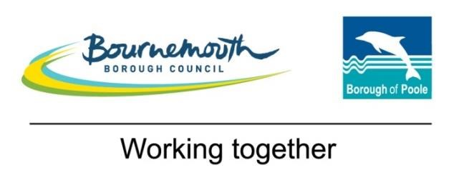**Role Profile (OG04)**

**Operational 4 (Grade 4/E)**

**Competencies**

|  |  |
| --- | --- |
| **Managing,**  **Leading and**  **Developing**  **Others** | **May act as a lead, allocating work and coaching others** |
| Contribute to and celebrate the success of the whole team |
| Encourage and listen to new ideas from everyone and be positive about change |
| Share open and honest feedback in a constructive manner |
| **Knowledge and Skills** | NVQ **3** (or equivalent experience) relevant to the role |
| Operational **experience** of specialised equipment and the safe application of procedures and techniques relevant to the role |
| **Good knowledge of the work practices, processes and procedures (including legal and regulatory requirements and the risks of non compliance)** **relevant to own area of work** |
| **Respond to a range of issues within set operational guidelines** |
| **Creativity and Innovation** | Use curiosity about the way things are done to recommend, create and implement more effective ways of working that will enhance customer experience |
| **Recognise and understand the impact of incidents arising, and d**evelop solutions to a range of practical problems |
| **Relationships** | Build supportive, positive and trusting relationships with others |
| Seek to resolve any barriers to collaborating with others by communicating openly and challenging unhelpful behaviour |
|  | Appreciate diversity in both customers and colleagues and consider their specific needs |
| **Proactively approach interactions with customers, using diplomacy and tact where issues could become contentious** |
| **Decision making** | Make evidence based **and outcome focussed decisions using proactive risk management and** within set procedures**, referring complex decisions** to a manager |
| **Work**  **Demands** | **Plan and organise own** workload**, including some** prioritisationof non standard work |
| Work requires physical effort and risk to personal safety |
| Elements of work are likely to be performed in challenging environmental conditions |

Version 1 – October 2017