

Parkstone Grammar School

Part-Time Cleaner

Applicant Pack
Parkstone Grammar School
Sopers Lane, Poole, Dorset, BH17 7EP
01202 605605
recruitment@parkstone.poole.sch.uk

Headteacher’s Welcome
As the headteacher of Parkstone Grammar School, it is my great pleasure to welcome you to our vibrant and dynamic school community. At Parkstone, we are committed to providing an exceptional educational experience that nurtures the intellectual, social, and emotional growth of every student.
We are a heavily oversubscribed 11-18 selective girls’ school offering outstanding education to the students of Poole and its surrounding area. Founded in 1905, Parkstone has continued to provide excellent academic results within a warm, friendly and vibrant community. We are a six-form entry school with 1250 students including 350 in the sixth form.
Our school is a place where students are encouraged to explore their passions, expand their knowledge, and develop critical thinking skills that will serve them well throughout their lives. We have a team of dedicated and highly qualified teachers and support staff who are passionate about education and are committed to inspiring and challenging our students.
We believe in creating a supportive and inclusive environment where each student feels valued and respected. Our students are rightly proud of their school which provides for them a broad and balanced curriculum promoting independence, intellectual curiosity and a love of learning. Subjects offered at GCSE and A Level include academic and facilitating subjects from a very wide range. Our sixth form collaboration with Poole Grammar School for Boys allows us to offer an extensive A Level curriculum.
Students at Parkstone are not only encouraged to succeed academically, but to enjoy the wide range of musical, theatrical, sporting, speaking and charitable opportunities. They thrive in an environment of support and challenge, becoming resilient learners well prepared to succeed in the 21st Century.
The unique single-sex selective environment allows the students to grow in a safe and supportive atmosphere. Parkstone’s national reputation for excellence and continued success is testament to the consistent dedication of students, staff and governors.
Ofsted commented that Parkstone offers a ‘stimulating, friendly community in which all students are valued and may thrive intellectually, emotionally and physically’. Our school’s focus is always on teaching and learning as we strive to challenge these able students to become confident, happy and successful young people.
I invite you to apply to our school, and experience the warm and welcoming atmosphere that makes Parkstone truly special. If you're ready to embark on a rewarding journey where your passion for education meets limitless possibilities, we encourage you to explore the opportunities at Parkstone. Join us in making a difference to our young people and shaping the future together.
David Hallsworth, Headteacher
Our Vision
At Parkstone, we embody the values of Commitment, Courage and Compassion to enable students to adapt and thrive in an evolving world, providing an education that inspires and empowers students to determine and achieve their goals.

COMMITMENT
“Be tenacious and relentless in your curiosity for knowledge”
COURAGE
“Feel confident to achieve your very best and develop your resilience to overcome barriers”
COMPASSION
“You should encourage and care for your peers, value and engage with all cultures and religions in our diverse global community”

“Parkstone has encouraged and inspired me to love learning. There is a great community and I am always supported – just like a family.”
Year 7 Pupil

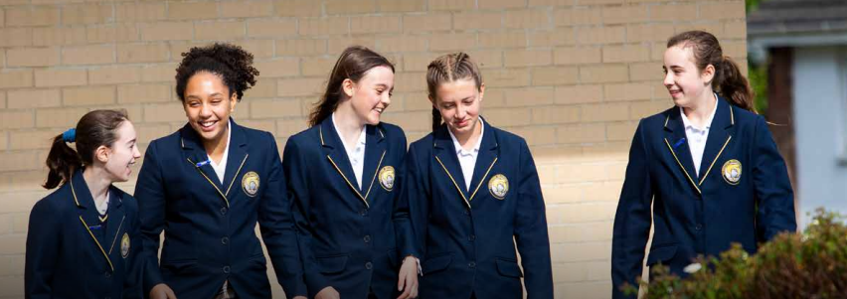

Our Guiding Principles
- Parkstone will be a seat of exceptional learning where great teachers enjoy autonomy in the classroom to inspire and challenge our able students.
- Very high-quality staff development and peer support to facilitate highly effective learning over time.
- Effective feedback to move students forward in their knowledge and skill development.
- Parkstone will achieve amongst the best schools in the country for the national progress measures at GCSE and A Level.
- A positive ethos underpinned by our values of Courage, Commitment and Compassion.
- Personalised support with highly effective intervention to enable equal access to learning.
- Students will have an understanding of global and national diversity and will be well prepared for life in an ever-evolving world.
- A strong community supported by the staff and student leadership teams.
- Compassionate, high quality advice and guidance to make informed and confident decisions regarding life after Parkstone.
- Opportunities outside the classroom which provide holistic development.
- To engage in initiatives and charity projects to contribute to the local and wider community.
- A broad, balanced and inspiring curriculum appropriate to Parkstone.
- An inspiring learning environment underpinned by a research culture and reflective practice.
- Our community will have high expectations of everyone in line with our Values and Charter.
- To instil a sense of stewardship towards our local, national and global environment.

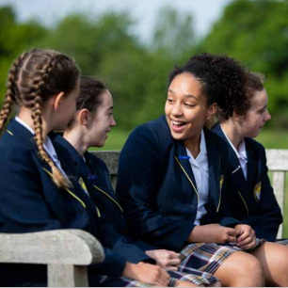
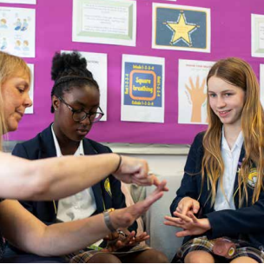

“Teachers are knowledgeable and enthusiastic. They inspire and sustain a love of learning in their pupils.”
Ofsted Report

Our School Charter
In our community it is important that we should maintain high standards and take responsibility for our own actions.

OUR COMMUNITY RESPONSIBILITIES
- To uphold the values of our school
- To treat all persons and the environment of the school with respect
- To apply ourselves to all areas of school life
- To empower all to do our best and to take care of each other
- To challenge any inequality and prejudiced attitudes

OUR RIGHTS
- To be treated with respect by all members of our community
- To feel safe both emotionally and physically in our school environment
- To participate in all the opportunities that our school offers
- To know where we can access support and guidance
- To be challenged appropriately where we fall short of our responsibilities


“Parkstone was the very best option for our daughter and has helped her grow in confidence and equipped her for university and life beyond!”
Parent

Ofsted
Key findings of this Outstanding School
“Under the headteacher’s calm, authoritative and exceptionally effective leadership, the school has improved rapidly since the previous inspection”.
“Leadership at all levels is very strong. Governors, senior leaders, middle leaders and other staff work harmoniously together to provide high-quality education for pupils”.
“Pupils make remarkable progress by the time they take their GCSEs in Year 11. This is sustained in the sixth form”.
“By the time they leave school, pupils have attained consistently at the highest levels and are extremely well prepared for the next stage of their education or employment”.
“Disadvantaged pupils make exceptional progress during their time at the school. Their rates of progress are much higher than other pupils nationally with the same starting points”.
“School leaders make very good use of targeted training to develop teachers’ professional knowledge and skills. As a result, teaching continues to improve”.
“Teachers are knowledgeable and enthusiastic. They inspire and sustain a love of learning in their pupils. Teachers have an unswerving faith in the ability of their pupils to succeed and give their time unselfishly to ensure that this happens”.
“Pupils are confident and articulate learners. They take great pride in their work and are determined to succeed”.
“Pupils’ behaviour is impeccable and their positive attitudes to learning are exemplary. They are hungry to learn and attendance rates are high, including in the sixth form”.
“The sixth form is outstanding. Students follow very well developed 16 to 19 study programmes”.
“Disadvantaged students prosper in the sixth form and in recent years all have gone on to university”.
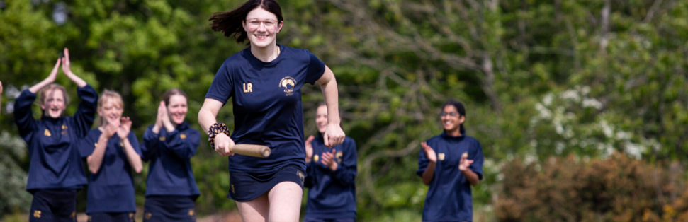

Benefits
Parkstone is pleased to be able to offer all staff members a
Core Benefits
- A contributory pension scheme relevant to your role (including access to Teacher and Local Government Schemes).
- Occupational sick pay.
- Tailored Continuous Professional Development (CPD) through the SIGMA Training School Alliance.
- Free access to the Employee Assistance Programme (EAP) - confidential support network that offers expert advice and compassionate guidance 24/7 covering a wide range of issues, such as: Legal Information, Bereavement Support and Online CBT among much more.
- All staff are entitled to a ‘Golden Day’ once a year – a paid day off or part time equivalent.
- Free Yoga and Pilates sessions throughout the term.
- Termly Staff Wellbeing and Workload groups to raise and solve issues.

Flexible Benefits
- Cycle to work scheme

Part Time Cleaner

The main purpose of this post is to carry out cleaning of the interior of the school to an agreed standard under the direction of the Cleaning Supervisor or Site Manager/Caretaker.

£11.44 gross per hour (aged under 21)

£11.59 gross per hour (aged over 21)

Monday to Friday 6.15 am – 8.15 am or 3.15 pm – 5.15 pm 10 hours per week

Term time plus compulsory hours to be worked during set days in the school holidays

To apply for this role, please complete the application form, which can be found on our school website, and send to recruitment@parkstone.poole.sch.uk

Job Description
SALARY AND HOURS OF WORK
Salary:
£11.44 gross per hour (aged under 21)

£11.59 gross per hour (aged over 21)

Hours of Work:
The normal working hours for this post during term-time are 10 per week, worked Monday to Friday 6.15 am – 8.15 am or 3.15 pm - 5.15 pm. There is an additional requirement to work some of the school holidays.
The postholder will be required to work 40 compulsory hours during school holidays to fit in with the requirements of the school; further details will be provided at interview.

Relationships:
Responsible to: Cleaning Supervisor and Site Manager/Caretaker
Regular contact with: Cleaning Supervisor, Site Manager/Caretaker and other cleaners regarding cleaning duties
General liaison with: Other school staff
The post holder will have no supervisory responsibility other than assisting with work familiarisation of peers and new recruits.

BASIC JOB DESCRIPTION

Main Job Purpose:
- Carry out the cleaning of the interior of the school to an agreed standard under the direction of the Cleaning Supervisor or Site Manager/Caretaker.
- Ensure the highest standards of cleanliness and general hygiene of the school premises.

Main Responsibilities and Duties:
- Clean hard surfaces, floor surfaces, walls, windows, fixtures, fittings and equipment as directed to an agreed standard, using powered equipment where appropriate.
- Be aware of Health and Safety issues around the building and work in accordance with safe practices and Health and Safety legislation.
- Report breakdown of any equipment or perceived hazards/incidents in the workplace to the Cleaning Supervisor or Site Manager/Caretaker.
- Ensure that good hygiene is maintained using separate cloths and mops for toilets, classrooms and food preparation areas.
- Complete any appropriate records or documentation required by the school.
- Maintain good working relationships with other school staff, and co-operate with reasonable changes to daily work routines to assist with the smooth operation of the school.
- Undertake such other duties as may be required from time to time commensurate with the level of the post. The particular duties and responsibilities attached to the post may vary from time to time without changing the general character of the duties or the level of responsibility involved.
- Comply with all decisions, policies and standing orders of the school and with any relevant statutory requirements, including Equal Opportunities legislation, the Health and Safety at Work Act and the Data Protection Act.
- Have a commitment to Child Safeguarding, to promoting the welfare of children and young people in accordance with the school’s agreed policy.

Work Environment:
- Routine cleaning duties may include the moving and handling of cleaning equipment, chemicals, machinery, and some movement of furniture.
- The cleaning duties will be undertaken indoors on school premises. On occasions this may include cleaning up of bodily fluids.
- In addition to cleaning, some lifting may be required.
- Cleaning equipment and materials including chemicals will be used regularly to undertake duties. Training and personal protective equipment will be provided.

KNOWLEDGE AND SKILLS

Qualifications, Experience and Training
- No formal qualifications or experience required
- Initial training in basic cleaning methods and use of materials and equipment will be provided within the induction period; further training may be provided thereafter as required

Attitude, Motivation and Ability
The post holder will be expected to:
- Be self-motivated
- Take a pride and interest in his or her work
- Have good interpersonal skills and to be able to work co-operatively within a team
- Have the ability to handle confidential information with discretion

Knowledge
The post holder will be expected to familiarise him or herself with:
- The Staff Handbook, including the policies and procedures contained within
- The school’s Fire and Emergency procedures
- The school’s Child Safeguarding procedures

Other Requirements
- To share the school’s commitment to Equal Opportunities
- To undertake an Enhanced Disclosure check by the Disclosure & Barring Service

Contact us
If you would like more information about Parkstone Grammar School please email recruitment@parkstone.poole.sch.uk

Alternatively, if you wish to discuss the vacancy please call 01202 605605 8.00 – 4.30 Monday to Thursday and 8.00 – 4.00 on a Friday.

Parkstone Grammar School
Sopers Lane, Poole, Dorset, BH17 7EP
