Job Description
Administration and Finance

Assistant (Seafront Catering)
Role Profile | Business Support Grade E
Service/Team | Seafront – Operations
Reports to | Catering Manager
Responsible for | N/A
Number of posts | 1
Post number | - - - - -
Career Grade | N/A
My job improves the quality of life for the people of Bournemouth and Poole by… Supporting the seafront catering team in the delivery of quality services and driving income opportunities for the visitors and residents of the resort.
Job Overview
To provide financial & administrative support to the seafront catering team.

Key Responsibilities
- Provide general administrative support to the seafront catering team
- Support the seafront catering team with the use of the debtor and creditors systems including assisting with the invoice process
- Assist seafront catering supervisors and manager with the HR processes including recruitment, interviews, induction process, staff training, timesheets.
- Assist the Seafront Catering Manager with the complaints, for the Seafront Catering team
- Work with the seafront catering team to ensure all Council practices and policies are adhered to
- To liaise regularly with other Council departments to ensure the Seafront Catering teams objectives are fully met
- Assist the Catering Marketing Team with projects and promotion delivery
- To administrate PierView Room enquires and bookings.
- Liase with suppliers to arrange deliveries and resolve stock queries
- To assist the Admin & Finance officer with general Seafront Admin when needed and to provide Admin support to Senior Officers.

Specific Qualifications and Experience
- Experience of working within a team with similar conflicting demands
- Knowledge of the Councils policies and procedures
- Experience of using Microsoft Word, Excel and Teams

Personal Qualities & Attributes
- Numerate
- Able to build effective relationships with team members
- Have a keen eye for detail

Job Requirements
- Must be willing to travel, using public or other forms of transport where they are viable, or by holding a valid UK driving licence with access to own or pool car
- To work in locations between Bournemouth and Poole as required
- Flexible working – 5 in 7 days, work over major festivals (e.g. Bournemouth Air Festival) and Bank Holidays.

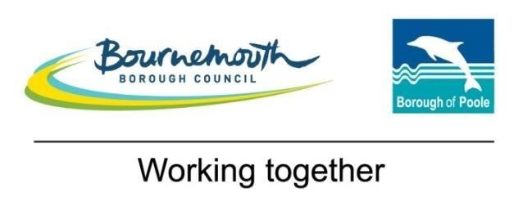
Role Profile (BSG04)
Business Support 4 (Grade 4/E)

Competencies
Managing,  Leading and  Developing  Others | Contribute to and celebrate the success of the whole team
Managing,  Leading and  Developing  Others | Encourage and listen to new ideas from everyone and be positive about change
Managing,  Leading and  Developing  Others | Share open and honest feedback in a constructive manner
Knowledge  and Skills | 2 A levels, NVQ 2/3 in Business Administration (or equivalent experience)
Knowledge  and Skills | Good knowledge of ICT including Excel, Word, Outlook and other programmes relevant to the role
Knowledge  and Skills | Straightforward collation and analysis of data
Knowledge  and Skills | Prepare engaging presentations using a clear brief
Knowledge  and Skills | Prepare clear and succinct meeting notes
Knowledge  and Skills | Experience of diary management for senior officers
Knowledge  and Skills | Attention to detail with the ability to proof read
Creativity and  Innovation | Use curiosity about the way things are done to recommend, create and implement more effective ways of working that will enhance customer experience
Creativity and  Innovation | Use effective interpersonal skills to develop solutions to a range of practical problems
Relationships | Build supportive, positive and trusting relationships with others
Relationships | Seek to resolve any barriers to collaborating with others by communicating openly and challenging unhelpful behaviour
 | Appreciate diversity in both customers and colleagues and consider their specific needs
Decision making | Make evidence based decisions within set procedures, escalating to a manager where appropriate
Work  Demands | Plan and organise own workload including some prioritisation of non standard work
Version 1 – September 2017

