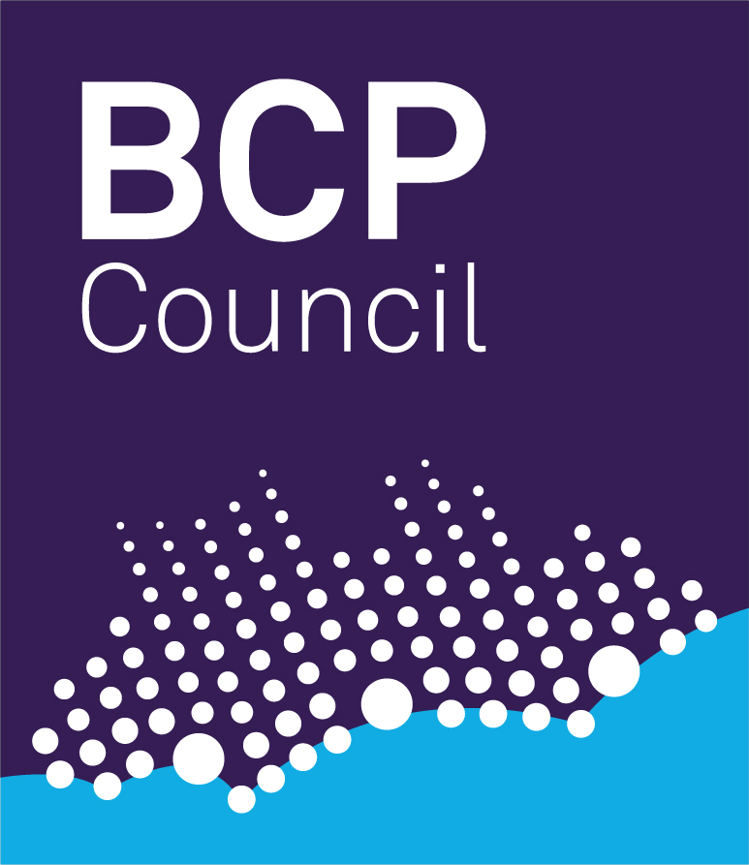

BCP Council

School Admission Appeal Panels - Appointment of Lay Members and People with Experience in Education

School Admission Appeal Panels

1. School Admission Appeal Panels are appointed to deal with appeals against decisions of the admission authority for a school (the local authority or the Governing Body of a school) to refuse admission to a child or children.

2. In Bournemouth, Christchurch and Poole, three persons serve at any one time on an Appeal Panel.

3. Each Appeal Panel must consist of at least one lay member and at least one member with experience in education.

4. The majority of appeals are heard between May and July prior to the admission of children at the beginning of a school year in September. However, appeals are heard throughout the year for a number of reasons, e.g. movement of families from one area to another. One singular appeal hearing may last a couple of hours, where as a grouped multiple appeal in the summer may last up to 10 consecutive working days.

5. Appeals are heard on weekdays during term time only.

6. The appeal hearings are in Bournemouth, Poole and Christchurch across a number of Council venues, privately contracted venues or schools and academies themselves.

Lay Members

7. A lay member is defined as a person without personal experience in the management or provision of education in any school (though it is permissible to use people who had experience as governors of other schools, or who have been involved in education in any other voluntary capacity.

People with Experience in Education

8. A person in this category is defined as a person with experience in education who is acquainted with educational conditions in the area, or who is the parent of a registered pupil at a school.

Disqualifications

9. The following persons are disqualified from membership of an Appeal Panel:-

a) any member of the local authority which is making the arrangements or which maintains the school in question;

b) any member or former member of the governing body of the school in question;

c) any person employed by the local authority or the governing body of the school in question, other than a person employed as a teacher or as a teaching assistant;

d) any person who has, or at any time has had, any connection with the local authority or the school, or with any person within paragraph c), of a kind which might reasonably be taken to raise doubts about his ability to act impartially in relation to the authority or the school;

e) any person who does not satisfy the training requirements as set out in the Appeals Regulations.

Payments to Panel Members

10. Members will be eligible for payment of travelling and subsistence allowances for attending Appeal Panel hearings and associated training, as well as reimbursement of care costs for dependents and loss of earnings.

Training of Members

11. Previous experience of Appeal Panels is not essential as those appointed will be given appropriate training before participating in hearings. Panel members are also expected to attend refresher training sessions.

Appointments

12. Those wishing to be appointed to the Appeal Panels for BCP Council should complete the application form which is available and return it in the pre-paid envelope supplied.

13. Following receipt of applications, those selected for short-listing will be invited for interview and references obtained prior to arranging fully training before being able to sit on a Panel.

Further Information

14. Further information about the appeals process in BCP can be viewed via www.bcpcouncil.gov.uk/schoolappeals

15. The School Admission Appeals Code which sets out how admission appeals operate can be viewed at https://www.gov.uk/government/publications/school-admissions-appeals-code

16. If you would like to discuss any aspects of the role of appeals panels, please contact Karen Green or Natalie Van Heerden, Appeals Officers on 01202 118911 or by email schoolappeals@bcpcouncil.gov.uk

